YOUR CLUB LOGO HERE 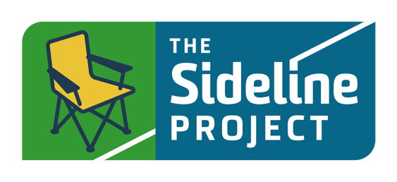

Dear Parents and Guardians

We are excited to participate with Twin Cities Soccer Leagues and The Sideline Project once again, and their club-wide competition for parental completion of an online course. This year we are asking you to participate by taking a 22 minute course called Winning on Gameday! The TCSL club with the highest percentage of parents completing the course will win! Important to note, this is a different course than last year’s competition. The competition runs from April 11 to May 12.

To participate:
- Go to https://Leader.TheSidelineProject.com/TCSL
- Fill out the registration form and click on “Take the Course”
- Once you have successfully completed the course, your first name, and our Club name, will be posted to the Pledge Wall found at the bottom of the page.
- Check back throughout the competition to see the progress of each club and how many of our TCSL families are taking the Pledge to improve the gameday experiences for everyone.

With your help, we will be able to significantly support our efforts to positively influence the gameday environments for our players and referees. Together, we can be part of positive change in youth sport and a leader of change in the soccer community.

We are fully committed to providing the best soccer experience for our players and we can't wait to see them all enjoying the game they love this coming season.

