YOUR CLUB LOGO HERE 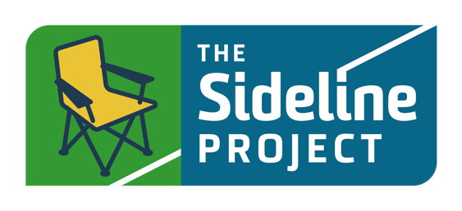

Dear Coaches,

Please support our efforts to improve the gameday experiences of players, coaches, referees, and spectators by encouraging your parents to participate in the Twin Cities Soccer Leagues - The Sideline Project club wide competition. This year we are asking parents to participate by taking a 22 minute course called Winning on Gameday! The TCSL club with the highest percentage of parents completing the course will win a VEO camera! Important to note, this is a different course than last year’s competition.

Attached to this email is a letter you can send directly to your parents. Please do so this week and check in with them to encourage them to participate. The competition runs from April 11 to May 12.

Directions for parents to participate:
- Go to https://Leader.TheSidelineProject.com/TCSL
- Fill out the registration form and click on “Take the Course”
- Once you have successfully completed the course your first name and our Club name will be posted to the Pledge Wall found at the bottom of the page.
- Check back throughout the competition to see the progress of our club and how many of our TCSL families are taking the Pledge to improve the gameday experiences for everyone.

With your help, we will be able to significantly support our efforts to positively influence the gameday environments for our players and referees. Together, we can be part of positive change in youth sport and a leader of change in the soccer community.

Coaches, we encourage you to join the competition and gain a deeper understanding of what your parents are learning by taking the course yourself as well!

We are fully committed to providing the best soccer experience for our players and we can't wait to see them all enjoying the game they love this coming season.

